Let’s Talk Hot Topics

**J. Wesley Webendorfer, JD, WCRA Lobbyist and Jackie Rupnow, RPR, CRI, WCRA President**

Grab something to drink and join us for Friday night’s session. Wes Webendorfer and Jackie Rupnow will be discussing current legislation that has been introduced regarding changing the notary public law. They will also be discussing a page rate increase for official reporters, the current climate for asking for such an increase, and talking with members about their thoughts regarding this topic.

 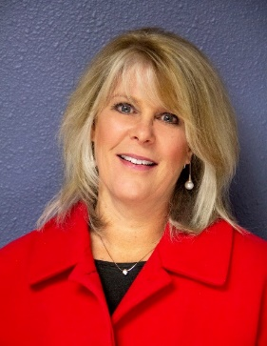

**Anissa Nierenberger, RPR, CRR, CRC, CRI**



We are so lucky to have Anissa Nierenberger joining us at this fall’s convention for not one but three sessions! Join us as we kick off Saturday morning with Terminate Transcript Turmoil. Anissa discovered captioning when she was just 14 years old after spending a career day with a reporter in court. Determined to become a stenographer, she pursued her goal and within a year of graduation from court reporting school, she began captioning for TV stations across the United States and Canada. Anissa is a past President of MAPCR (Michigan Association of Professional Court Reporters) and has been a member of NCRA (National Court Reporters Association) for over 25 years. She has presented seminars on realtime, captioning, dictionary building, and Dictionary Jumpstart to state and national associations. Anissa Nierenberger has pursued her passion for captioning into three distinct areas; Anissa Captions, her proprietary software Dictionary Jumpstart, and training and education programs. Anissa will present three separate seminars for us at The Osthoff.

**Terminate Transcript Turmoil**

What if a small change in HOW you edit could result in better realtime in only two weeks. This means much shorter editing time to crank out a transcript! We’re going to spin you 180 degrees from how you do things now and show you just how much time and energy you are going to save. This is one seminar you will not want to miss! “Simple Syllables” book complements this seminar.

**Terminate Transcript Turmoil 2**

We’ll review the SADA concept from the original TTT, talk about families of prefixes and suffixes and the importance of consistency! Anissa will talk about valuable word pieces, how to make stacking work FOR you, and how FPP55 earns you better realtime in only one week! This presentation builds upon TTT.

**Fantabulous Brief Families**

All happy families are alike and learning family briefs is fun and easy! Families inspire us and these briefs will inspire you, too. They’re consistent, like-minded, and become a masterpiece when adopted. The ^dom brief family has 8 members, the ^line brief family has 25 members, and the a^ family has 56 members. These are a small example of the families that we’ll get to know in our hour together!

**STEPHANIE BELLIN**



Stephanie has 26+ years of Human Resources experience working with various industries. Join us Saturday morning as Stephanie will talk to our members about Cultural Sensitivity – Diving Deeper into Unconscious Bias. Unconscious biases are learned stereotypes that are automatic, not intentional, can be deeply engrained, sometimes universal and are able to influence behavior. This training is designed to identify unconscious bias, help the participant identify their personal unconscious biases, provide tools to adjust patterns of thinking, examine where do their unconscious biases come from and provide a cultural sensitivity challenge and tools to assist in broadening knowledge, while teaching the participant how to establish healthy boundaries given the existence of unconscious bias.

**Lance Boardman, RDR, CRR, NCRA Rep**

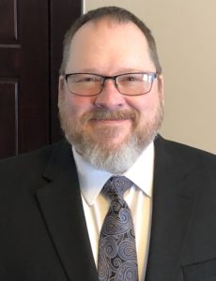

In his 35 years as a court reporter, Lance Boardman has been a freelance reporter, a state official, and an independent contractor. He is now a federal official court reporter for the Northern District of Ohio, Eastern Division. He holds the nationally recognized professional certifications of Registered Diplomat Reporter (RDR), Registered Merit Reporter (RMR), Registered Professional Reporter (RPR), and Certified Realtime Reporter (CRR).  
At the national level, Boardman has served on NCRA’s Education Content Committee and as a regional director on the National Committee of State Associations Governing Committee.

Boardman has been a member of a number of state associations over the years, as well as USCRA, The Society for the Technological Advancement of Reporting (better known as STAR), and Texas Depositions Reporters Association. He most recently served as a district director and then secretary on the Ohio Court Reporters Association Board of Directors.

Lance will talk to us about Technology. Today’s new technology is yesterday’s news. Staying at the top of your game is vital to your success in the court reporting and captioning arenas. We will explore the impact technology has had on our profession and the importance of staying current with new technology to ensure that you support the services you provide your clients. The presentation includes an overview of some of the latest in hardware and software products.

**Jackie Rupnow, RPR, CRI, WCRA President**

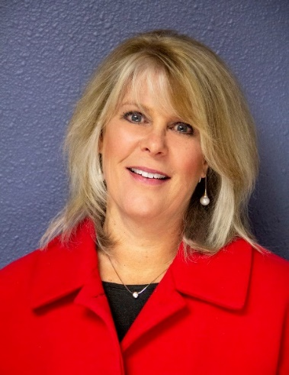

**Town Hall**

Join WCRA President Jackie Rupnow for a Town Hall session that will showcase the latest in what your state association is doing for you, and share your thoughts and insights in an open dialog and Q & A following the presentation.

**Edmund Jelinski, JD**

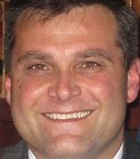

Our final speaker on Sunday morning will be Attorney Edmund Jelinski. Mr. Jelinski is a former assistant district attorney who was fired in 2002 by Former Winnebago County District Attorney Joe Paulus after he blew the whistle on the alleged bribes-for-leniency deals. Ed Jelinski said Paulus was a unique character who used the immense power of his office to intimidate those who questioned him. The Paulus incident was a monumental point in Jelinski’s career, and since then he has been working in private practice.