Ed Johnson - "Reporting on Capitol Hill:
Witnessing History in the Making"

Edward H. Johnson, RPR, CRR, FAPR, graduated with a court reporting degree from Madison Area Technical College in 1980. He freelanced for one year in Milwaukee. From 1981 to 2007, Ed was an official reporter for Marinette and Ozaukee County Circuit Courts in the state of Wisconsin. Ed then became an Official Reporter for the House of Representatives in May of 2007 where he has worked reporting for committees as well as on the floor of the House. He has been president of the Wisconsin Court Reporters Association, an NCRA RAINmaker, NCRA legislative advisor, Chair of the NCRA Future Group, and served on the nominating committee and ER Task Force.

What is it like to be an Official Reporter to the House of Representatives in Washington, D.C.? What does the job entail, and what training is required? How does one get a job reporting for Congress? How do you handle 435 different speaker identifications? Ed Johnson from Wisconsin will share the answers to these and other questions as he relates his personal experiences as an Official Reporter for Congress.

Attendees will also learn some of the history of making the record in the House of Representatives and the Office of Official Reporters. Ed will also discuss the humorous elements of being a court reporter. In telling tales from school, freelancing, being a state official, and legislative reporter, Ed helps the attendees view difficult employment situations through a different mind-set and find humor and stress relief in their work life.

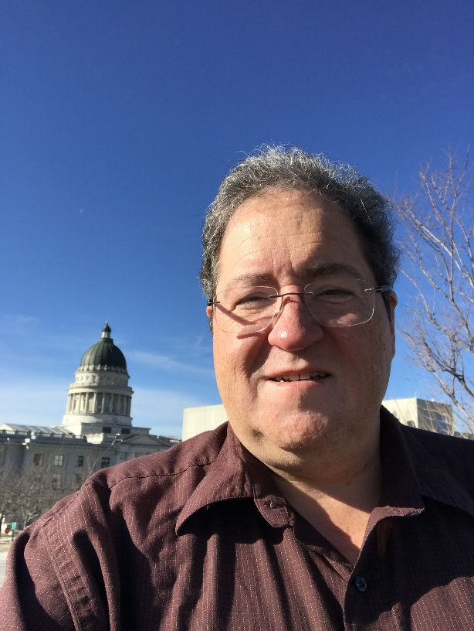

Pat Nelson
Pat Nelson has been in the business of court reporting for 46 years and has experience in freelance reporting and captioning. She was co-owner of Northwestern Court Reporters/Riverside Captioning Company from 1973-2014 when she sold the business to go into full-time captioning on a subcontractor basis with her LLC company of Pat Nelson Captioning. She holds the certifications of Registered Merit Reporter, Certified Realtime Reporter, and Certified Realtime Captioner. During her years of owning a freelance court reporting firm, she has mentored several reporters, has encouraged her employees to become realtime ready, and has trained those interested in expanding into captioning/CART.
Pat has been captioning since 1994 and has experience in every area of captioning and just about every type of programming. She has traveled around the country captioning on-site for large stadium events and also locally for stadiums, conferences, small groups, and one-on-one. Remotely she captions both national and local television programming as well as large and small conferences and business calls using the internet or phone lines. Pat is excited to share her experiences and knowledge.
Adventures in Captioning
Our members want more seminars related to CART and captioning, and you got it! Pat Nelson will talk about her career as a freelance reporter/firm owner, how she transitioned to captioning, and the process she went through. She will also talk about some of her "adventures" in captioning and explain how she prepares for the many different areas of captioning she works in, taking each one separately. Pat will discuss the equipment and technologies used for each captioning area, how she preps for jobs, and some tips for on-site work, whether huge stadium events and conferences or small venues. She will also discuss captioning remotely for television, business calls, governments, conferences, and students. In Pat’s own words, “I have done it all, and hopefully I can be informative and also entertaining.”
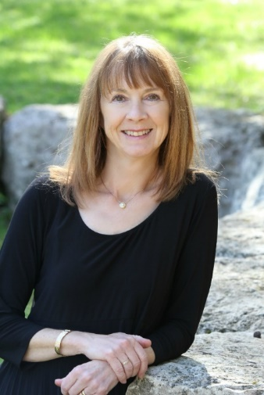
Cindy L. Isaacsen

I am from the great state of Texas!! I went to the Stenograph Institute of Texas from 1985 – 1988, which is when I passed the Texas exam. I have lived and worked in Tennessee, Kansas, Louisiana, and all over Europe (Germany, Italy, France, Belgium, Holland). I am now an official for Johnson County, Kansas. I am in my 30th year of reporting. I have been both freelance and official depending on my location and my life situation. I have been certified in Texas, Louisiana, Kansas, Missouri, and finally decided the RPR was the way to go.

After serving two years as president, I am now the immediate past president of the Kansas Court Reporters Association. I am currently serving NCRA as the Vice-Chair of NCSA. I have five children, one grandbaby and one on the way, a very patient husband, and a new addition – our dog, Molly. I frequently attend career fairs or visit with high school and middle school students discussing our great profession and the need for more reporters.

How to save your job? Be Proactive, Not Reactive!!

I will be bringing with me the financial stats of live reporter versus DR, examples of DR disasters – and, boy, there are many. I have a slide show that was presented to the Supreme Court and the Senate Judiciary Committee. I will tell you our story and how we as a state became proactive with our legislature through our association and our lobbyist and will encourage your state association and its members to get involved and make a difference.

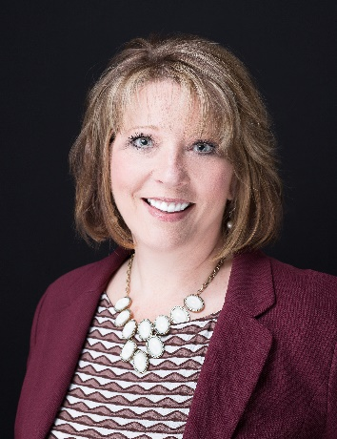

THOMAS W. JOHNSON, ESQ.

Thomas Johnson practices with the law firm of Werner, Johnson & Hendrickson, SC, in New London, Wisconsin. Tom has been licensed for 33 years.
Tom grew up in Waupaca, Wisconsin. He graduated from the University of Wisconsin-Stevens Point in 1976 with highest honors. Tom taught eighth grade civics in Ashland, Wisconsin, for four years. He left teaching to consider buying Ding’s Dock on the Waupaca Chain O’Lakes.

In 1985, Tom graduated from the University of Wisconsin Law School at the top of his class. After two years at Foley & Lardner in Milwaukee, he returned to Waupaca to practice “small town” law.

Attorney Tom Johnson’s presentation will include an enlightening discussion of the proper and improper uses of humor in the courtroom and how to know when a line needs to be drawn. Tom’s presentation will also include a discussion of an article that appeared in the ABA Journal by Philip N. Meyer, “Don’t Underestimate the Value of Comedy in the Courtroom.” As court reporters already know, there is a value of humor being utilized to effectively lift the many intense moments in depositions and in the courtroom. This presentation will take you on that journey.

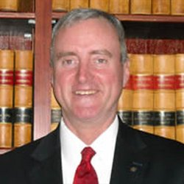

Merilee S. Johnson

Merilee S. Johnson has been reporting for 19 years and has experience as an official reporter, freelance reporter, and captioner. Currently, she serves as Director of Reporter Relations and Technologies with Paradigm Reporting and Captioning. In addition to her extensive work experience, Merilee is credentialed as a Certified Independent Training Agent with Stenograph. She holds NCRA’s RDR, CRR, CBC, and CCP certifications as well as NCRA’s RSA Certificate.

Merilee serves the industry as a member and chair for multiple committees on both the state and national levels. She has a long history of mentoring students and reporters and currently serves as an Adjunct Instructor at Anoka Technical College teaching Realtime Reporting and Technology. She is a resource for reporters at Paradigm and the local court reporting school, an active trainer for Stenograph, and is also a member of STAR’s Liaison Committee.

Tech Gadgets and Gizmos

Back by popular demand, Merilee will lead a session filled with dozens of specific gadgets, gizmos, and app recommendations to make life easier both on and off the job. Put distance between you and your competition with these functional and fun tools. From hardware to apps, you'll be ahead of the pack.

WILLIAM GRAY
William Gray is a 25-year veteran of military, state, and local law enforcement. He served as a military policeman and investigator in the U.S. Army and Army Reserve for 12 years, deploying to and conducting criminal investigations in Kansas, Puerto Rico, Korea, Kuwait, and Iraq.
As a civilian, he has worked as a deputy sheriff for Dunn and Chippewa Counties in Wisconsin as well as a city police officer in Colfax and Cornell, Wisconsin. During those times he has served as an investigator, investigating financial crimes, fatal crashes, general crimes, and child abuse cases. Gray also served in an undercover capacity for three years as narcotics investigator assigned to the West Central Drug Task Force in west central Wisconsin.
While with the Chippewa County Sheriff’s Office, William was assigned to the Chippewa Combined Response Team as an entry team member and a sniper. William also volunteered as an Honor Guard member of the Chippewa County Honor Guard team and as a state-certified firearms instructor and still teaches today.
Since returning from Iraq in 2005, he continued to work conducting military investigations until his honorable discharge from the Army in 2008, attaining the rank of Staff Sergeant. Gray has been awarded the Meritorious Service Medal, the Global War on Terrorism Expeditionary Medal, the Global War on Terrorism Service Medal, an Army Commendation Medal, two Army Achievement Medals, Armed Forces Service Medal, National Defense Service Medal, three Overseas deployment medals, the Humanitarian Service award for assisting Puerto Rican civilians and military after hurricane Hugo in 1989, and the Armed Forces Expeditionary Medal.
William is currently working as a Special Agent with the Wisconsin Department of Revenue. He has over 25 years of experience teaching law enforcement subjects for the military and state and local government. Gray holds an Associate’s Degree in Criminal Justice from the Chippewa Valley Technical College and is a certified Military Police Investigator. He also holds Statement Analysis, Sniper, Rural SWAT, Honor Guard, and Firearms certifications among other certifications required to be a law enforcement officer. William was awarded the Wisconsin Professional Police Meritorious Award and the U.S. Immigration and Customs Enforcement Partnerships for Public Safety Award for 2014.
On November 14, 2014, while working as a financial crimes investigator for the Chippewa County Sheriff’s Office, Gray was viciously attacked by a 19-year-old male from the United Kingdom who attempted to take Gray’s life. Gray survived 14 stab wounds to his face, throat, and left hand losing a total of five pints of blood. Gray went back to work three months later and is still a certified law enforcement officer in Wisconsin. Gray’s motivation is now to teach law enforcement officers and civilians alike in the art of not becoming a victim and what it takes to survive in a life-or-death situation. Gray’s company motto is Prepare, Practice, and Perform.
William has been married to his wife, Sara, for 25 years and is the proud father of one son and two daughters.

Last One Standing Strategies
On November 14, 2014, after 25 years in law enforcement and training others how to be tactically sound and to go home safely after each shift, I suffered over a dozen stab wounds to my face, throat, and left hand. However, thanks to God, his intervention, and my training, I was able to survive and go home to my family. I now want to help others by being there for you, your family, and your community as an inspirational speaker.

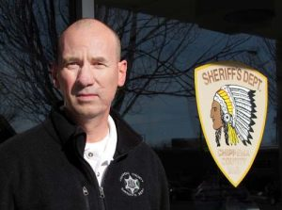

Cindy L. Isaacsen

Oh, the Places You Can Go ….. (but what do I do when I get there?)

Our amazing career has taken me many places and provided me countless opportunities. I will share my experiences of living and working in many states and abroad. Not only have I moved physically, but I have also moved professionally. I went from a position of “just doing my job and not really caring about the profession” to one of making a difference. I once shied away from board service, and now I find myself a leader for my state and national associations. I have not always taken advantage of all the opportunities, but I will share with you how you can start looking for open doors and how to knock on closed ones. I will share my adventures with you and guide you in your path to leadership.

